Sustainable Gastronomy Book: Students will create a recipe book including **plant based traditional food.**

**PREPARE 1 EXAMPLE PER STUDENT (HAVE YOUR RECIPE READY)**

**Lisa Korpershoek – Dutch apple pie** 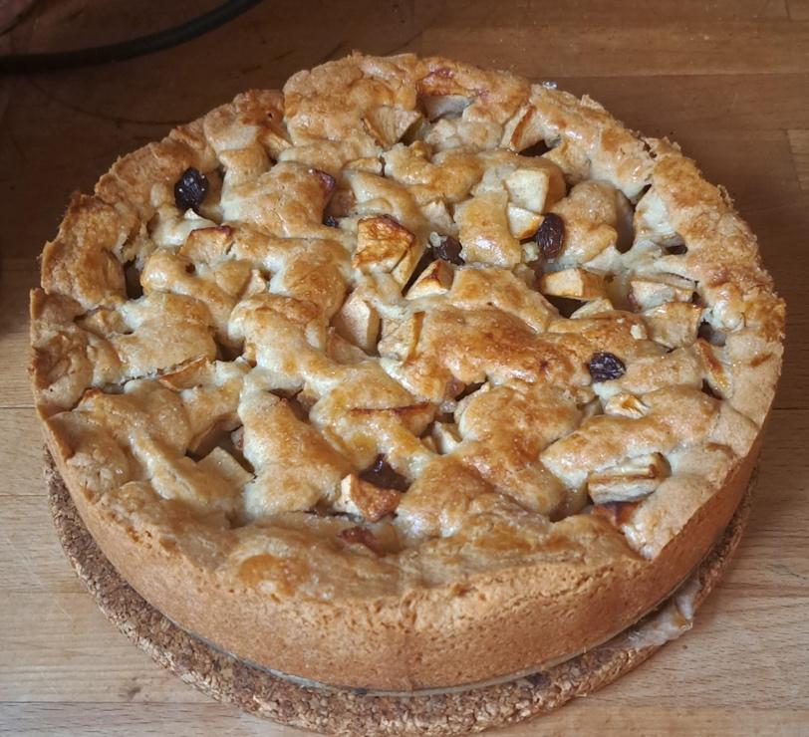

Ingredients

* 1 packet apple pie mix
* 175g butter
* 1 egg
* 1kg apples
* 75g raisins
* 20g sugar
* 2 or 3 tsp cinnamon

Other necessities

* Spring form
* Mixer

Preparation

1. Put the raisins in lukewarm water for 15 minutes. Afterwards, dry with a paper towel.
2. Put a roster in the middle of the oven and preheat it to
   1. 180°C electric oven
   2. 165°C hot air oven
   3. 3-4 gas oven
3. Coat the springform in butter.

Prepare the dough

1. Stir the butter until soft in a large bowl and whisk an egg in a separate bowl. Put ⅔ of the egg and the pancake mix in with the butter.
2. Knead until combined.

Prepare the filling

1. Peel the apples, remove the core and cut them into cubes.
2. Mix the apple cubes with the sugar, cinnamon and raisins.
3. Put ⅔ of the dough on the bottom and sides of the springform.
4. Put the filling in the form.

Make the top

1. Put a little bit of flower on the counter and roll what is left of the dough into strips.
2. Press the strips a little flat and put them criss-cross on the pie.
3. Take what is leftover of the egg and put it on the top of the pie.

Baking

1. Put the apple pie in the oven for ~60-75 minutes.
2. Let it cool in the springform for 1 hour before taking it out.

**Ties Lokhorst – Dutch Pancakes** *“Pannenkoeken” (with dutch cheese, stroop, sugar or apples+raisins)*

Ingredients:

* 300g flower
* 1 tsp salt
* 500 ml milk
* unsalted butter
* (Toppings: cheese, stroop, sugar, marmalade, nutella or apples and raisins)

Other necessities:

* Whisk or mixer
* Pan
* Bowl
* Ladle

Steps:

1. First put the flower in the bowl, add the eggs and half of the milk and mix with a whisk until it's smooth. Pour the rest of the milk in the bowl and mix again until it’s smooth.
2. Heat a knob of butter in a frying pan. Put some of the batter in the pan with the ladle. (add cheese or apples+raisins if you want) Rotate the pan so that the entire bottom is covered.
3. Let the pancake (pannenkoek) bake and then flip the pancake and let it bake for another minute.
4. Repeat until your batter is gone.
5. After all your (cheese)pancakes are ready, you can add your toppings.

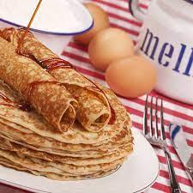

*stroop*

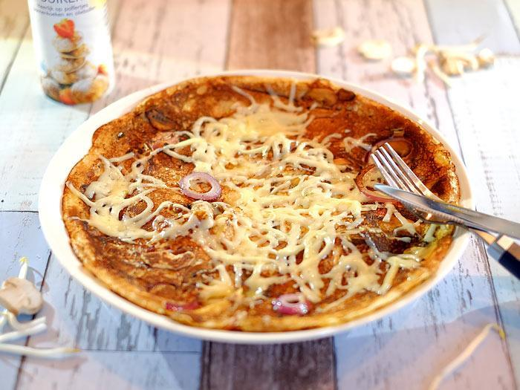

*cheese*

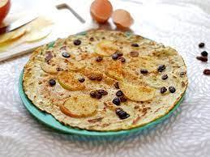

*Apple+ raisins*

**Manu de Lange - Dutch “Stroopwafels”**

Ingredients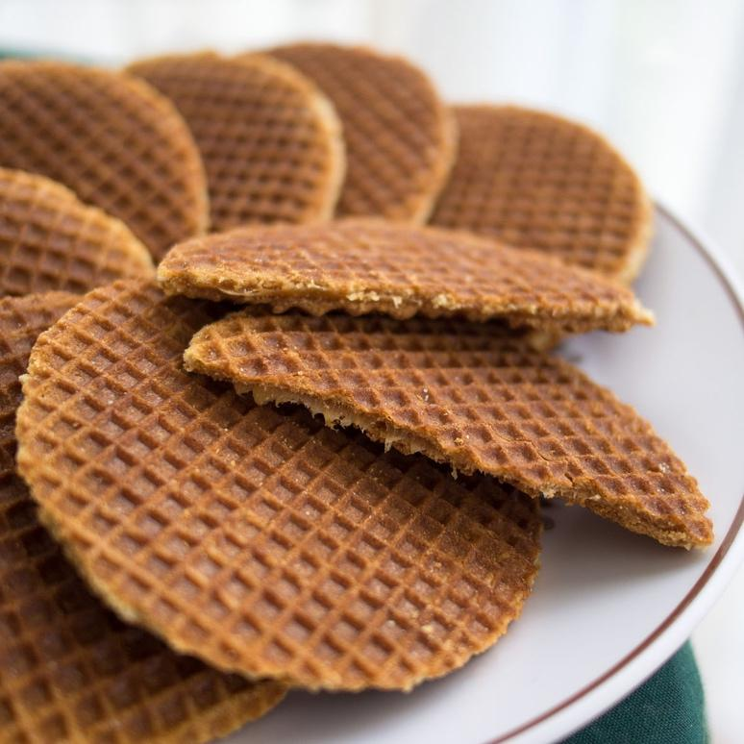

*Needed for the dough*

* 30 ml milk, lukewarm
* 10 gr dried yeast
* 300 gr flour
* 150 gr butter, at room temperature
* 90 gr white caster sugar
* 1 egg at room temperature
* ¼ tsp salt

*Needed for the filling*

* 200 gr sugar syrup
* 100 gr light brown caster sugar
* 75 gr butter

Further needed items

* Butter or neutral oil to grease the waffle iron
* Recipe for 15-20 waffles

Mix the lukewarm milk with the dried yeast. Add the flour, butter, caster sugar, egg and salt to the mixture. Mix until there is an even dough. Cover the bowl with plastic foil and leave it at a warm draught-free place.

For the filling, pour the syrup into a saucepan and let it warm up while stirring it. Add the light brown caster sugar and the butter, let the mixture boil for one or two minutes while stirring. Wait until all the sugar crystals have dissolved.Remove the saucepan from the stove and add, if wanted, a bit of cinnamon.

Bake the stroopwafels.

Preheat the waffle iron as warm as possible and grease it with butter.

Make little balls of dough, weighing 30-40 grams each. Bake them ball by ball on the waffle iron in three minutes until they are golden brown. Cut immediately after cooking the edges so you are left with a round shape with a diameter of around 10 cm. And then cut the waffles in half with a sharp knife. Apply the sugar syrup to one side and then you put the other side back on. There you have it, the classic stroopwafel.

**Iwan Snel - Croatian Francuska salata**

Ingredients:

* 5 hard boiled eggs
* 5 medium/large potatoes
* ~400 grams of pickles
* 750 grams of peas and carrots (or a small jar of both separately, 400 grams each)
* Mayonnaise
* Salt and pepper
* A mixing bowl

Steps:

Let the carrots, peas and pickles drain. Boil the potatoes in slightly salty water long enough so that they become soft, but still firm enough to be chopped in pieces. (≈10 minutes)

Chop the carrots, eggs and potatoes in small pieces/cubes, and add them in a large bowl

Add mayonnaise until the salad becomes creamy, but not fatty. Then add pepper and salt to taste and you’re done!

People usually eat this dish with bread or as a side dish.

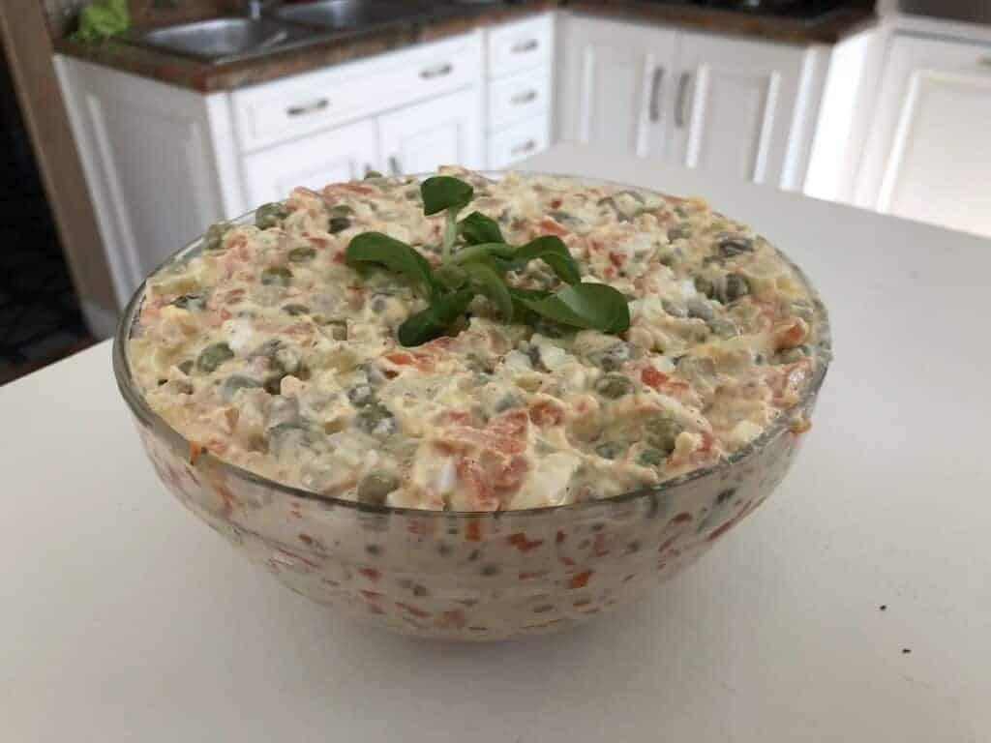

**Mustafa Avci – Oliebollen**

Ingredients:

* 250 ml luke warm milk
* 250 gr flower
* 7 gr dried yeast
* 2 tbsp brown sugar
* ½ egg
* 150 gr raisins
* 500 ml sunflower oil
* Pinch of salt
* Powdered sugar

Steps:

Put the raisins in a bowl of water for 15 minutes. Combine the yeast, sugar and milk and let it rest.

Mix the flower, salt and milk mixture until the mixture is sticky. Add the egg and the raisins and mix gently.

Place a wet towel over the bowl and let it rest for 60 minutes. The mixture should rise.

In a large pot, heat the sunflower oil and make little balls of the dough. Drop the dough in the large pot and stir the oil a few times. Cook till golden brown. Let the oliebollen rest on a piece of kitchen towel and sprinkle them with powdered sugar.

